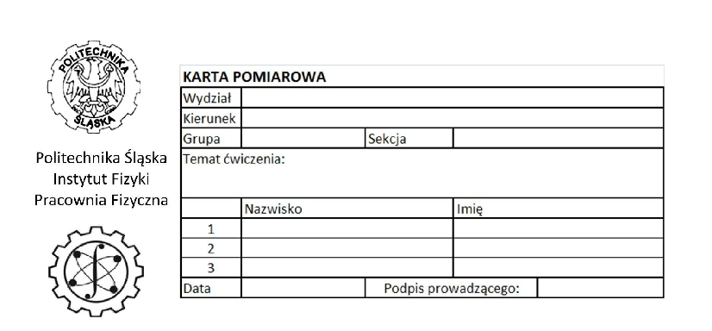

l
n
x
t
Δm
Δl
Δx
Δt
R
d
ΔR
Δd

